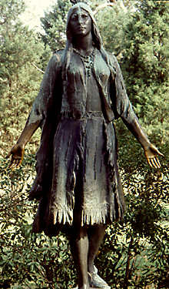
Pocahontas: Savior or Savage?
Ivor Noel Hume

Directions: Answer these questions based on your reading of the essay by Hume.

- What event prompted the state of Virginia to commission a bronze statue of Pocahontas?

- Why would it have been difficult for Powhatan’s men to find “two great stones” near their village?

- What is a weroance?

- The writer mentions two instances in which the Powhatan Indians performed executions. What method did they use each time? Does this make Smith’s claim seem more or less believeable?

- The author suggests that Pocahontas had a specific role in what happened to Smith. Why did this role fall to her and not to someone else?

- In his 1608 account, Smith says that Powhatan planned to keep him prisoner how long?

- By 1612, Smith claims to have impressed the Indians so much that they admired him as much as they would have admired a “demi-God.” What is a demi-god?

- In what year did Smith first claim that Pocahontas had saved his life?

- The author claims that people in the late 1800s wanted to believe this story. What had happened to make them want to believe in a gentler time?

- The author mentions various portraits of Pocahontas, implying that the bronze statue mentioned at the beginning is just one more portrait. List three and give a fact about each.

This writer focuses on how people have “seen” the John Smith/Pocahontas story. Write a paragraph summarizing his views. (A summary includes the main ideas and the most important details in your own words.)

